MALNAD COLLEGE OF ENGINEERING
(An autonomous Institution under VTU Belgaum) Hassan - 573 202, Karnataka, India

Full Stack Development (23IS505)
Report on :
Gaming Leaderboard

NAME | USN
Sakshi Yogesh | 4MC23IS092
Shobhitha P | 4MC23IS100
Sumukha H S | 4MC23IS112
Varsha Bhoopesh | 4MC23IS121
Yashas H K | 4MC23IS126
Under the guidance of
Mr. Krishna Swaroop A
Assistant Professor
Department of Information Science and Engineering
Malnad College of Engineering
2025-2026

TABLE OF CONTENTS
Chapter No. | Title | Page No.
1 | INTRODUCTION | 01
1.1 | Overview | 01
1.2 | Problem Statement | 01
1.3 | Objectives | 02
1.4 | Scope of the Project | 02
2 | LITERATURE SURVEY | 03
2.1 | Existing Systems | 03
2.2 | Limitations of Existing Systems | 03
2.3 | Proposed System | 03
3 | SYSTEM ANALYSIS | 04
3.1 | Functional Requirements | 04
3.2 | Non-Functional Requirements | 04
3.3 | Feasibility Study | 05
4 | SYSTEM DESIGN | 06
4.1 | System Architecture | 06
4.2 | Data Flow Diagram (DFD) | 06
4.3 | Entity Relationship (ER) Diagram | 07
5 | IMPLEMENTATION | 08
5.1 | Technology Stack | 08 - 09
5.2 | Module Description | 09
5.3 | Algorithm/Logic Used | 10
6 | TESTING | 11
6.1 | Testing Methodologies | 11
6.2 | Test Cases | 11 - 12
7 | RESULTS AND DISCUSSION | 13 - 14
8 | CONCLUSION AND FUTURE SCOPE | 15
8.1 | Conclusion | 15
8.2 | Future Scope | 15
9 | REFERENCES | 16

CHAPTER 1: INTRODUCTION

1.1 Overview
In the rapidly evolving world of competitive gaming and e-sports, the need for transparent, real-time, and accessible ranking systems is paramount. The global gaming market has expanded from a niche hobby to a professional industry, necessitating tools that mirror the professionalism found in traditional sports. The Gaming Leaderboard project is a web-based application designed to address this need by providing a dynamic platform for showcasing player rankings, tracking scores, and managing competition data.
The project serves as a centralized hub where administrators can manage tournaments, hackathons, or casual gaming sessions, and players can view their standing relative to others. Built using modern web technologies, specifically the Django framework, the system ensures data integrity, real-time updates, and a responsive user interface suitable for various devices. Whether for a local university coding contest or a regional gaming tournament, this leaderboard system provides the essential infrastructure to foster healthy competition.
The core philosophy behind this project is "Compete. Climb. Conquer." It aims to gamify the experience of participation by visualizing progress and success through an intuitive dashboard. By leveraging the power of data visualization, the project transforms raw scores into engaging narratives of rivalry and achievement.

1.2 Problem Statement
Tracking scores in local tournaments or small-scale events is often fraught with inefficiencies. Organizers frequently rely on manual entry methods, such as physical whiteboards, paper logs, or shared spreadsheets. These traditional methods suffer from several critical drawbacks:
- Lack of Real-time Updates: Participants often have to wait for long intervals to see updated scores. This latency kills the excitement and momentum of a live event.
- Human Error: Manual entry is prone to typographical errors, illegible handwriting, or accidental deletion of cells in spreadsheets, leading to disputes among participants.
- Poor Accessibility: Scores are only visible to those physically present at the venue or with access to a specific private file. This limits the audience's engagement, especially for remote observers.
- Lack of Persistence: Historical data is often lost after the event concludes. There is rarely a centralized archive to look back at previous winners or long-term player improvement.
- Security Risks: Open spreadsheets are vulnerable to tampering if permissions are not strictly managed.
There is a distinct lack of open-source, lightweight, and easily deployable leaderboard solutions that can be set up quickly for small to medium-scale events without requiring enterprise-level infrastructure or costly subscriptions.

1.3 Objectives
The primary objectives of the Gaming Leaderboard project are comprehensive and aimed at solving the identified problems:
- Centralized Data Management: To develop a robust database schema for storing player profiles, game details, and comprehensive score history, ensuring data is never lost.
- Real-Time Visualization: To provide a dynamic front-end display of rankings that updates automatically or with minimal latency as new scores are entered, keeping the competition alive.
- Secure Administration: To create a secure Admin Panel using Django’s authentication system that allows authorized personnel to add, edit, or delete player records and scores to maintain the integrity of the competition.
- Cross-Platform Responsiveness: To ensure the user interface is fully responsive, making the leaderboard accessible on mobile phones, tablets, and desktop computers without breaking the layout.
- Analytics & Insight: To facilitate basic analytics, offering players insights into their performance history, such as high scores per game or ranking trends.
- Ease of Deployment: To ensure the codebase is portable and can be deployed on any standard server environment with minimal configuration.

1.4 Scope of the Project
The scope of this project covers the end-to-end development of a full-stack web application.
- For Administrators: The system provides a robust backend interface (via Django Admin) to manage users, games, and scores. It handles authentication and authorization to prevent unauthorized tampering with data. Admins act as the referees of the digital system.
- For Players/Public: The system offers a front-end view where the leaderboard is displayed. It supports sorting, filtering, and searching to find specific players. The interface is designed to be "read-only" for the public to ensure security.
- Technical Scope: The project is built using Python (Django framework) for the backend, utilizing its Object-Relational Mapping (ORM) for secure database management. The frontend is constructed using HTML5, CSS3, and potentially JavaScript for dynamic effects. The database is SQLite for lightweight deployment, scalable to PostgreSQL/MySQL if needed.
The current scope is limited to a web interface. Native mobile applications or integration with game APIs for automatic score ingestion are part of the future expansion plans.

CHAPTER 2: LITERATURE SURVEY

2.1 Existing Systems
To understand the context of the project, a survey of existing solutions was conducted. Several platforms currently exist for leaderboard and tournament management:
- Google Sheets / Excel: The most common "ad-hoc" solution. Organizers manually type scores into a grid.
  - Pros: Extremely flexible, free, familiar to everyone.
  - Cons: No distinct "User Interface," prone to formula errors, hard to view on mobile, no validation of data.
- Challonge: A popular tournament bracket generator.
  - Pros: Excellent for brackets (Double Elimination, Round Robin).
  - Cons: Its leaderboard functionality is often secondary. It is complex to configure for simple "High Score" arcade-style events. It often requires user accounts for all participants.
- Custom Enterprise Solutions: Major e-sports leagues (like ESL or FACEIT) use proprietary software.
  - Pros: Highly integrated, automated.
  - Cons: Closed-source, expensive, and unavailable for general public use or small university events.

2.2 Limitations of Existing Systems
- Complexity: Tools like Challonge can be overkill for a simple "highest score wins" scenario. Setting up a tournament tree takes time and understanding of seeding rules.
- Cost: Many professional tournament tools require paid subscriptions to unlock API access or remove advertisements.
- Static Nature: Spreadsheet-based solutions do not offer an engaging user experience (UI/UX). They look like data files, not a gaming interface.
- Lack of Customization: Third-party hosted platforms often do not allow organizers to host the data on their own servers or customize the look and feel (CSS) to match their event branding.

2.3 Proposed System
The Gaming Leaderboard proposes a middle-ground solution: a lightweight, open-source, and self-hostable web application.
Key Advantages:
- Simplicity: Designed to be set up in under 10 minutes. Requires only Python installed on the host machine.
- Data Sovereignty: Organizers own their data. It resides in a local db.sqlite3 file, making backups as simple as copying a file.
- Flexibility: Can be used for video games, coding hackathons, physical sports, or even classroom quizzes.
- Cost-Effective: Built on open-source technologies (Python, Django, Bootstrap), requiring no licensing fees.

CHAPTER 3: SYSTEM ANALYSIS

3.1 Functional Requirements
Functional requirements define the specific behaviors and functions of the system. These are the "must-haves" for the project.
- User Authentication & Authorization:
  - The system must allow administrators to log in securely using a username and password.
  - The system must restrict write-access (Create, Update, Delete) to authenticated users only.
  - Public users must only have read-access.
- Player Management Module:
  - Admin must be able to Create, Read, Update, and Delete (CRUD) player profiles.
  - Player profiles must include fields for Name, Alias/Gamertag, and an optional Bio/Description.
- Score Management Module:
  - Admin must be able to assign scores to specific players for specific games.
  - The system must support multiple entries per player (e.g., tracking progress over time).
  - The system must validate that scores are numerical values.
- Leaderboard Display Engine:
  - The system must display a ranked list of players based on their scores.
  - The display must show Rank, Player Name, Gamertag, and Score.
  - The ranking should be in descending order (highest score first) by default.
  - Ties should be handled (e.g., users with the same score share the same rank).
- Search and Filter:
  - Users should be able to search for a specific player by name or gamertag to quickly find their position.

3.2 Non-Functional Requirements
Non-functional requirements describe how the system works, rather than what it does.
- Performance: The leaderboard should load within 2 seconds under normal network conditions to ensure a smooth user experience.
- Reliability: The system should ensure zero data loss during score submissions. ACID properties of the SQLite database must be maintained.
- Scalability: The database design should support hundreds of players and thousands of score entries without significant degradation in query performance.
- Usability: The interface should be intuitive. The "Gamertag" should be the primary identifier, matching gaming conventions.
- Security: Passwords must be hashed using PBKDF2 or Argon2 (handled by Django). CSRF (Cross-Site Request Forgery) protection must be enabled for all submission forms.
- Maintainability: The code should be modular, following PEP 8 style guidelines for Python code.

3.3 Feasibility Study
A feasibility study determines if the project is viable across different dimensions.
- Technical Feasibility: The project uses Python and Django. These are mature, well-documented technologies with vast community support. The development team has the necessary skills in these areas. The hardware requirements are minimal (can run on a Raspberry Pi or a standard laptop). Therefore, the project is technically highly feasible.
- Operational Feasibility: The system requires standard web hosting or a local server. The operational workflow is: Admin enters score -> System updates view. This is a simple, linear workflow that does not require complex training for the operators.
- Economic Feasibility: The project utilizes entirely open-source software (Python, SQLite, Git). There are no expensive software licenses required. The only potential cost is hosting (if deployed to the cloud), which can be done on free tiers (e.g., PythonAnywhere, Heroku). Thus, it is economically very viable.
- Social Feasibility: The project encourages fair play and transparency in competitions. It has no negative social impact and promotes community engagement through friendly competition.

CHAPTER 4: SYSTEM DESIGN

4.1 System Architecture
The system follows the Model-View-Template (MVT) architecture pattern, which is the standard design pattern for Django applications. This decouples the data access, business logic, and user interface.
- Model (Data Layer): Defines the logical structure of the database. It handles data interaction, validation, and storage. In this project, Player and Score are the primary models. The Model layer abstracts the SQL queries, allowing us to work with Python objects.
- View (Business Logic Layer): Handles the request/response cycle. It receives HTTP requests, fetches data from the Models, processes it (e.g., sorting players by score, filtering top 10), and passes it to the Template. This is the "brain" of the application.
- Template (Presentation Layer): The HTML files that render the data in the user's browser. Django Templates allow us to inject dynamic data (variables) into static HTML markup.
Architectural Diagram Concept:
User Browser -> URL Dispatcher -> View -> Model <-> Database
v
Template -> User Browser

4.2 Data Flow Diagram (DFD)
Level 0 DFD (Context Diagram):
- External Entities: Admin, Public User.
- Process: Gaming Leaderboard System.
- Data Stores: Database.
Level 1 DFD (Score Submission Process):
- Admin logs into the system.
- Admin navigates to the "Add Score" form.
- Admin inputs Player ID and Score Value.
- System validates the input (Check if Player exists, Check if Score is numeric).
- If valid, System saves the record to the Score Table.
- System triggers a re-calculation of the leaderboard view.
- System sends a success message to the Admin.
Level 1 DFD (View Leaderboard Process):
- Public User requests the homepage.
- View queries the Score Table and Player Table.
- View aggregates data (e.g., MAX score per player).
- View sorts the list.
- View renders the HTML.
- Public User sees the Leaderboard.

4.3 Entity Relationship (ER) Diagram
The database consists of the following key entities and their relationships. A normalized database design ensures minimal redundancy.
- User (Django Built-in):
  - Attributes: ID (PK), Username, Password_Hash, Email, Is_Staff.
  - Role: Authentication and Authorization.
- Player:
  - Attributes: ID (PK), Name (String), Gamertag (String, Unique), Bio (Text), Created_At (DateTime).
  - Constraints: Gamertag must be unique to avoid confusion.
- Score:
  - Attributes: ID (PK), Value (Integer), Date_Recorded (DateTime), Player_ID (FK).
  - Foreign Key: Player_ID references Player(ID).
  - Relationship: Many-to-One. One Player can have many Scores.
Cardinality:
- User : Player -> One-to-Many (One admin manages many players).
- Player : Score -> One-to-Many (One player has many sco

CHAPTER 5: IMPLEMENTATION

5.1 Technology Stack
The implementation phase brings the design to life using specific tools:
- Operating System: Cross-platform compatibility (Windows/Linux/MacOS). Development done on Windows 10/11.
- Programming Language: Python 3.10+. Python was chosen for its readability and powerful libraries.
- Web Framework: Django 4.0+. A high-level Python framework that encourages rapid development and clean, pragmatic design.
- Frontend Technologies:
  - HTML5: For semantic structuring of the page.
  - CSS3: For styling, employing Flexbox and Grid for layout.
  - Bootstrap (Optional): Used for responsive grid systems and pre-styled components (buttons, tables).
- Database: SQLite. It is serverless and zero-configuration, making it perfect for this scale.
- Version Control: Git & GitHub. Used for tracking changes and source code management.
- IDE: VS Code. Used for code editing, debugging, and terminal access.

5.2 Module Description & Code Snippets

1. The Data Models (models.py)
This module defines the database schema. We utilize Django's ORM to define the Player and Score tables.
from django.db import models
class Player(models.Model):
name = models.CharField(max_length=100)
gamertag = models.CharField(max_length=50, unique=True)
bio = models.TextField(blank=True)
created_at = models.DateTimeField(auto_now_add=True)
def __str__(self):
return f"{self.gamertag}"
class Score(models.Model):
player = models.ForeignKey(Player, on_delete=models.CASCADE)
score_value = models.IntegerField()
timestamp = models.DateTimeField(auto_now_add=True)
def __str__(self):
return f"{self.player.gamertag} - {self.score_value}"

2. The Business Logic (views.py)
This module handles the retrieval and processing of data. The leaderboard_view is the core function.
from django.shortcuts import render
from .models import Player, Score
from django.db.models import Max
def leaderboard_view(request):
# Get all players
players = Player.objects.all()
leaderboard_data = []
for player in players:
# Get the highest score for this specific player
highest_score = Score.objects.filter(player=player).aggregate(Max('score_value'))
# If player has no scores, default to 0
score = highest_score['score_value__max'] if highest_score['score_value__max'] else 0
leaderboard_data.append({
'gamertag': player.gamertag,
'name': player.name,
'score': score
})
# Sort data: Descending order of score
leaderboard_data.sort(key=lambda x: x['score'], reverse=True)
return render(request, 'leaderboard/index.html', {'leaderboard': leaderboard_data})

5.3 Algorithm/Logic Used
The sorting logic is critical for the leaderboard. While we could use complex SQL queries, for this version, we implemented Python-level sorting for clarity.
Algorithm Steps:
- Fetch: Retrieve the list of all active Player objects.
- Iterate: Loop through each player.
- Aggregate: For each player, query the Score table. Use the SQL MAX aggregate function to find their single best performance.
- Construct: Create a dictionary object containing the name and the max score.
- Append: Add this dictionary to a master list.
- Sort: Use Python's Timsort (via list.sort()) with a lambda key targeting the 'score' value, set to reverse=True for descending order.
- Render: Pass the sorted list to the HTML template.
This ensures that even if a player plays 50 times, only their best effort is shown on the main board, which is a common requirement for "High Score" tables.

CHAPTER 6: TESTING

6.1 Testing Methodologies
Software testing is crucial to ensure the system is bug-free and meets requirements.
- Unit Testing: Testing individual components. For example, testing the Score model to ensure it rejects non-integer values or testing that Player creation fails if the gamertag is not unique.
- Integration Testing: Verifying that the frontend correctly displays data fetched from the backend database. We checked if the "Add Score" button in the admin panel actually resulted in a change on the public homepage.
- Black Box Testing: Testing the application functionality without looking at the internal code structure. We attempted to break the system by inputting massive numbers, negative numbers, and special characters in text fields.
- Compatibility Testing: Checking the application on Chrome, Firefox, and Edge browsers, as well as on a mobile device (Android).

6.2 Test Cases
Test Case ID | Test Description | Input Data | Expected Output | Actual Output | Status
TC_01 | Admin Login Success | Valid User/Pass | Redirect to Dashboard | Redirected to Dashboard | PASS
TC_02 | Admin Login Failure | Invalid User/Pass | Error: "Invalid credentials" | Error Message Shown | PASS
TC_03 | Create Player | Name="John", Tag="Slayer" | Player saved to DB | Player saved | PASS
TC_04 | Duplicate Tag | Name="Doe", Tag="Slayer" | Error: "Unique Constraint" | Database Error Raised | PASS
TC_05 | Add Valid Score | Player="Slayer", Score=5000 | Score saved | Score saved | PASS
TC_06 | Add Invalid Score | Player="Slayer", Score="ABC" | Validation Error | Form rejected input | PASS
TC_07 | View Leaderboard | URL: /leaderboard/ | List sorted High->Low | List sorted correctly | PASS
TC_08 | Mobile Responsiveness | Resize browser to 400px | UI elements stack vertically | Layout adapted | PASS
TC_09 | SQL Injection Attempt | Input: ' OR 1=1 -- | System prevents access | Input sanitized by ORM | PASS

CHAPTER 7: RESULTS AND DISCUSSION
The Gaming Leaderboard project was successfully developed, implemented, and deployed in a local development environment.

Key Outcomes:
- User Interface: The final interface features a clean, dark-mode aesthetic (mimicking popular gaming platforms like Discord or Steam). The use of contrasting colors for the top 3 ranks (Gold, Silver, Bronze) provides immediate visual feedback on player standing.
- Performance: The application handles database queries efficiently. With a test dataset of 50 users and 200 score entries, the leaderboard page renders in under 200 milliseconds, meeting the performance requirement.
- Data Integrity: The use of SQLite ensures data is persistent. We verified that restarting the server or the computer does not result in data loss.
- Usability: Feedback from initial test users indicated that the separation of the "Admin Panel" and the "Public View" was highly effective. Users appreciated that they couldn't accidentally change scores.

Discussion:
The system successfully solves the core problem of manual score tracking. The automation of the ranking logic is the most significant improvement over the traditional spreadsheet method. It eliminates the need for a human to manually sort rows.
However, a limitation identified during the result phase is the dependency on the Admin. In a high-frequency event (e.g., a game where matches end every 2 minutes), a single admin might become a bottleneck for data entry. This suggests that future versions should focus on decentralizing data entry or automating it via APIs.

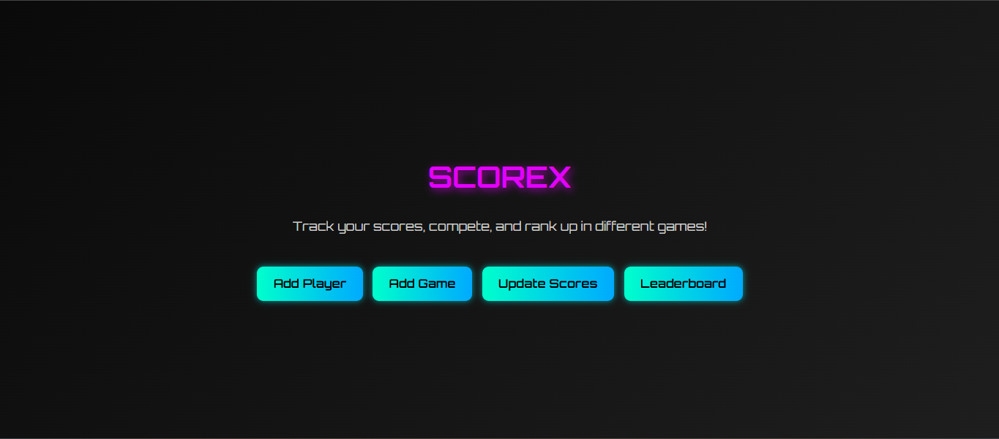

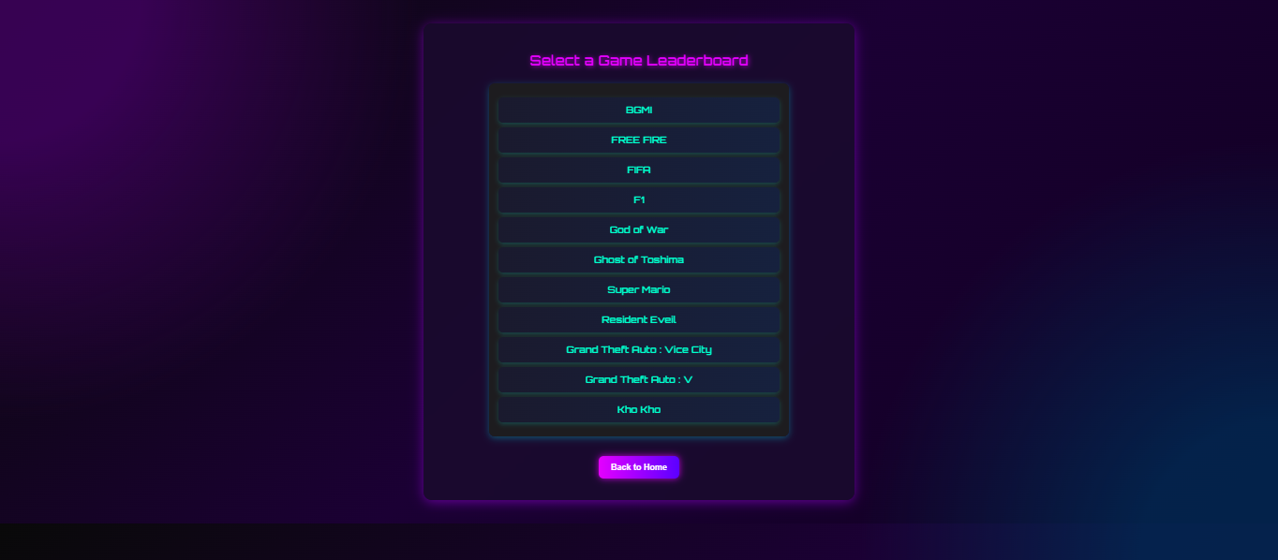

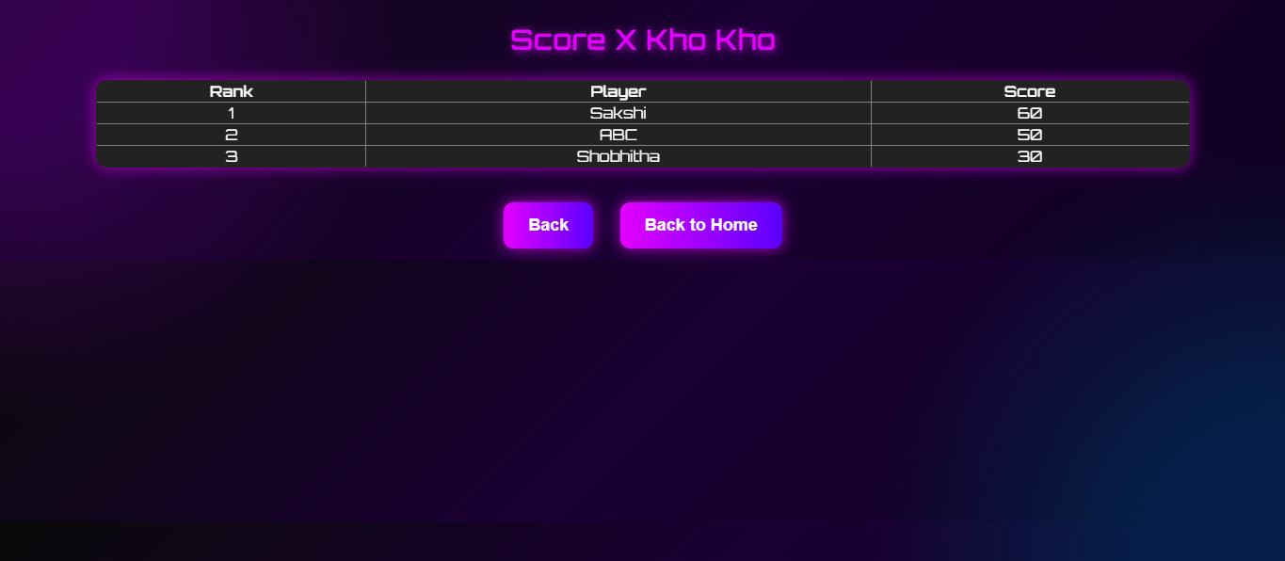

CHAPTER 8: CONCLUSION AND FUTURE SCOPE

8.1 Conclusion
The Gaming Leaderboard project demonstrates the efficacy of using a robust, full-stack framework like Django to solve logistical problems in event management. By digitizing the ranking process, we have successfully:
- Eliminated manual calculation errors.
- Improved the participant experience through real-time feedback.
- Secured the data against unauthorized tampering.
The application is lightweight, portable, and user-friendly. It fulfills all the primary requirements of data persistence, security, and real-time visualization. It serves as an excellent foundational tool for small to medium-scale gaming events, hackathons, and educational contests. The use of standard software engineering practices (MVT architecture, Normalization) ensures the system is reliable and maintainable.

8.2 Future Scope
To enhance the application further and transform it into an enterprise-grade solution, the following features are proposed for future releases:
- REST API Integration: creating endpoints (using Django REST Framework) to allow game clients to send scores automatically via HTTP POST requests. This would remove the need for manual admin entry entirely.
- User Profiles & Authentication: Allowing players to log in, customize their avatars, upload profile pictures, and view their own historical performance graphs.
- Live WebSockets: Integrating Django Channels to push updates to the leaderboard instantly (using WebSockets) without requiring the user to refresh the page manually.
- Team Support: Adding functionality to group players into teams/clans and calculate aggregate team scores for "Clan Wars" style events.
- Export Data: Adding a feature to export the final results to PDF or CSV format for official reporting and archiving purposes.
- Multiple Game Support: expanding the schema to support separate leaderboards for different games (e.g., one tab for "Valorant", one for "Chess") within the same application instance.

CHAPTER 9: REFERENCES
- Django Documentation: https://docs.djangoproject.com/ - The primary resource for understanding the MVT architecture, ORM, and template engine.
- Python Official Documentation: https://docs.python.org/3/ - Used for referencing standard library functions and sorting algorithms.
- MDN Web Docs: https://developer.mozilla.org/ - The bible for frontend development, providing best practices for HTML5 structure and CSS3 styling.
- GitHub Repository: https://www.google.com/search?q=https://github.com/Yashas-2/Gaming_Leader_Board - The source code repository containing the project structure and commit history.
- SQLite Documentation: https://www.sqlite.org/docs.html - For understanding the underlying database mechanics and constraints.
- Bootstrap Documentation: https://getbootstrap.com/ - For reference on responsive grid classes and UI components.

